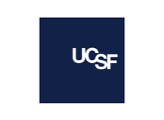Pipeline Programs within UCSF Department of Anesthesia and Perioperative Care

- FACES for the FUTURE Coalition
  - At UCSF, we are committed to serving our diverse communities. The Department of Anesthesia and Perioperative Care at Zuckerberg San Francisco General Hospital, has provided shadowing opportunities as part of the “FACES for the FUTURE Coalition” program. In 2000, the FACES program was established in Oakland, CA, to provide much needed health career, wellness, and leadership development to support our diverse youth.
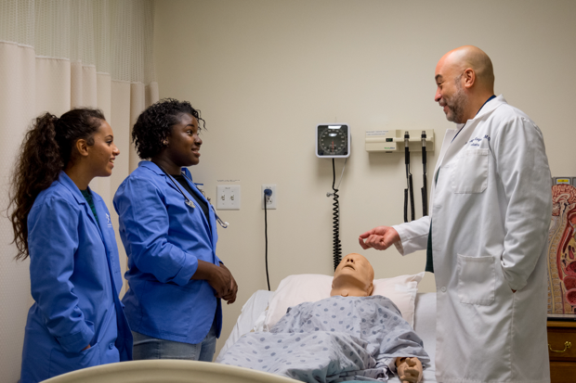
Assistant Professor of Anesthesia and Medical Director of the ZSFG preoperative evaluation clinic, Dr. Laura Lang, was fortunate to have precepted 5 students over 4 months through the FACES program. These local students spent Wednesday mornings in various anesthesia locations, and were generally from diverse and disadvantaged backgrounds. After completion of the 7-week session, the students shared written quotes about their experiences, including:
"Thank you for allowing me to shadow and observe a variety of health care professions regarding anesthesiology. I appreciate that you created an inclusive and positive learning environment for me to thrive in. I've learned so much about the important role anesthesiology has in surgery. This internship has inspired me to possibly pursue a career as an anesthesiologist"
"I got to see things I never would've thought I seen at this age. I'm so thankful that you got me to see a C-section because being an OBGYN is my dream job and being able to be exposed to that was awesome."
We look forward to continuing to partner with leading innovators in academia, science, technology and industry in pursuit of our public mission.

- UCSF Students Capturing the Operating Room Experience (SCORE)
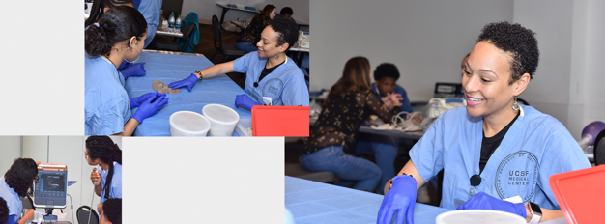
  - In 2018, Associate Professor of Anesthesia and Perioperative Care and John A. Watson Scholar, Charlene Blake, MD, PhD, conceived of and led the first Students Capturing the OR Experience (SCORE) program, an opportunity for local high school students from underrepresented backgrounds to have first-hand exposure to multiple health sciences careers, mentors, and role models.

On February 19, 2021, the third annual SCORE program took place on a virtual format for the first time, with hands-on learning stations, lectures by UCSF community members sharing their career trajectories and tips, exposure to actual procedures in the operating rooms, small group discussions, and more, for 27 local high school students.

- UCSF/Kaiser Permanente Undergraduate Research Internship (URI) Program
  - Founded in 2009, the UCSF/ Kaiser Permanente Undergraduate Research Internship (URI) was created to build a supportive pathway for underrepresented University of California, Berkeley, students interested in a career in medicine to address specific challenges these students face. Annually, URI engages 16 interns in a meaningful summer research project, clinical shadowing at UCSF and Kaiser Oakland, didactics, leadership training, and extensive mentoring during the 8-week program. The program directors, within the OB/GYN department, and URI Anesthesia Liaison also offer mentoring through the medical school application process.
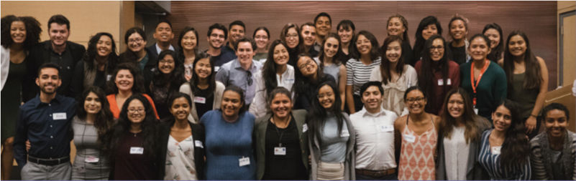
The URI program scholars usually start first week of June and sign up for clinical shadowing opportunities in the OR with anesthesia faculty for half a day as part of their program experience. In the summer of 2019, the scholars had the opportunity to shadow Pedi-anesthesia, Neuro-anesthesia, Cardiac-anesthesia, ICU, as well as Spine and OB-anesthesia. These experiences were a highlight for them inspiring them to keep plugging away in their premed courses at Berkeley. Three of the scholars also have the opportunity to be paired with clinical researchers within the UCSF Department of Anesthesia & Perioperative care for 8 weeks.

- Helix Program
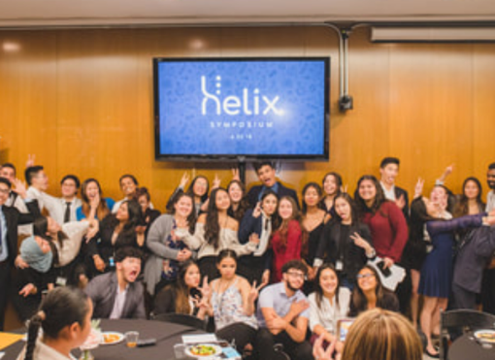
  - The Helix Summer Medical Program is a free, four-week program in the Bay Area that guides students through an exploration of different careers in the healthcare field. The first week of the program is an overnight stay on the UC Berkeley campus from Saturday through Friday, featuring a Core Curriculum comprised of lectures, biological and clinical labs, and professional development. In this week, students will also develop a research project to be presented to family members and community health professionals at the culminating Helix Symposium.
For the following two weeks, students participate in Clinical Shadowing with four different preceptors across the pre-hospital (Emergency Medical Services), community clinic, and hospital settings (Anesthesia, Surgery, Family Medicine, etc.) and rotate through these placements. Every Friday, students return to UC Berkeley for Berkeley-UCSF Joint Medical Program faculty-led Clinical Shadowing Debrief sessions to openly share and discuss their weekly shadowing experiences. In the fourth and final week, students venture through site visits including, but not limited to the Kaiser Permanente Garfield Medical Innovation Center, UCSF Cadaver Lab, and UCSF Medical School.

